# Introduction to Chemical Synthesis (Pearson 14.4)

* Chemical synthesis refers to forming a new chemical substance from others.
* The chemical synthesis pathway refers to a series of chemical reactions that convert a starting material into a product in several steps.
* When deciding on the preferred pathway, different possible reaction pathways must be considered regarding the availability of reactants, yield, rate, cost, safety, and sustainability.

## Production of Esters (An example of chemical synthesis)

The manufacture of the ester, ethyl ethanoate, is achieved in three steps.

Hydrolysis is a reaction involving the breaking of a bond in a molecule using water.

#### Hydrolysis means 'split with water'.

***Step 1 -* Ethanol** is synthesised directly by the hydrolysis (addition reaction with water) of ethene in the presence of the catalyst, phosphoric acid:

H3PO4

Image result for ethane to ethanol

steam

ethanol

ethene

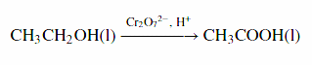***Step 2* - Ethanoic acid** is synthesised by the total oxidation of the primary alcohol ethanol (using acidified permanganate or dichromate):

ethanoic acid

ethanol

Condensation is a [reaction](https://en.wikipedia.org/wiki/Chemical_reaction) in which two [molecules](https://en.wikipedia.org/wiki/Molecule) combine to form a larger molecule, together with the loss of a small molecule.

#### Condensation reactions usually ‘releases water'.

***Step 3 -* Ethyl ethanoate** is produced by the condensation reaction (esterification) between ethanol and ethanoic acid (using a sulfuric acid catalyst):

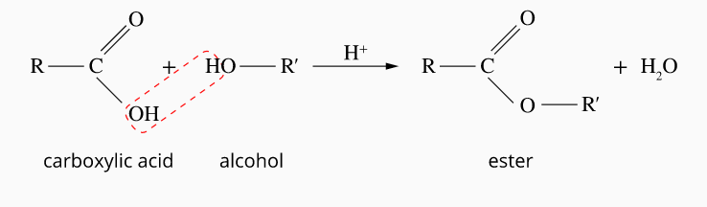

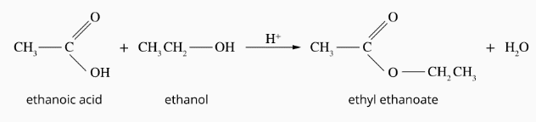

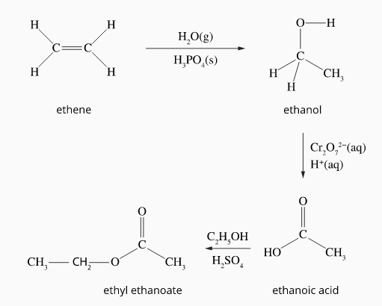

(ethanol)

(steam)

**The reaction pathway for the production of ethyl ethanoate**

# http://haber-bosch-process-tan-ser-jin.weebly.com/uploads/4/4/6/5/44657017/6085989_orig.jpgThe Haber Process (Pearson 11.3)

**Fractional Distillation** is a process where aliquid mixture is separated into fractions by using differences in boiling point

|  |  |
| --- | --- |
| Air Fraction | Boiling Point OC |
| N2 | -196 |
| O2 | -183 |
| Ar | -186 |
| CO2 | -79 |



## Reagent Sources

* The nitrogen is obtained from the fractional distillation of liquefied air (78% N2).
* Hydrogen is usually obtained from hydrocarbons (readily available from fossil fuels) through a dual-stage process called steam reforming. For example:

CH4(g) + H2O(g) (Steam) ⇌ CO(g) + H2(g)

CO(g) + H2(g) ⇌ CO2(g) + H2(g)

**Steam Reforming** is a method for producing hydrogen, carbon monoxide, or other useful products from fossil fuels such as natural gas.

This process involves steam reacting with the fossil fuel at elevated temperatures.

## Increasing Reaction Rate (Collision Theory)

The Haber process reaction rate can be increased by:

* High temperatures
* Use of a catalyst
* High partial pressures of gaseous reactants

## Increasing Reaction Yield (Le Châtelier's Principle)

The reaction yield would be increased by shifting the equilibrium to the right. This would be achieved by using:

* Lower temperatures (The Haber process is exothermic. Therefore, the equilibrium will be shifted to the right to increase the temperature).
* High pressures (equilibrium will shift right to reduce the number of moles of gas).

(NB: A catalyst does not affect the reaction yield. Its only effect is to increase the rate of the reaction.)

## Reaction Conditions Summary

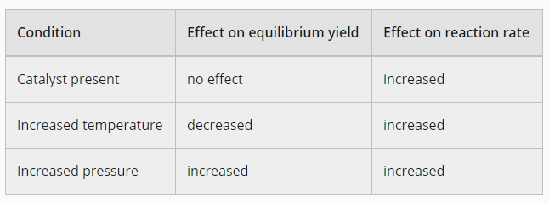

## The Compromise

The harbour process is best run at:

* High pressures (100-250 atm) (to increase yield and rate).
* Moderate temperatures (350∘C to 550∘C) to ensure sufficient yield while maintaining a reasonable reaction rate.
* A porous iron/iron oxide, Fe3O4, catalyst produces the best increase in the rate at high pressures and moderate temperatures.

# Commercial Process

A simplified industrial setup is shown in the following diagram:

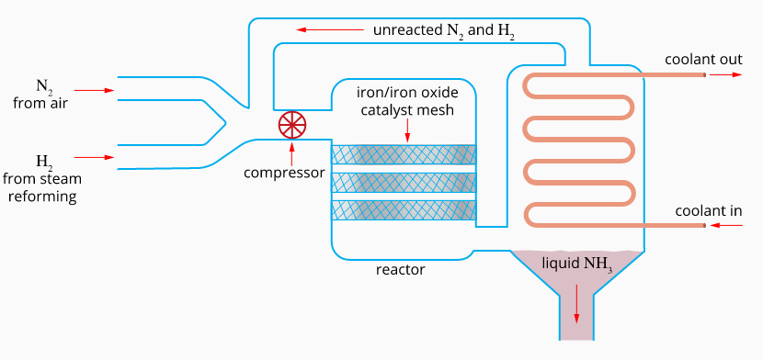

## Process Summary

* The ratio of gas volumes pumped into the reactor is 1:3 N2:H2 (the stoichiometric ratio required for equilibrium)

|  |  |
| --- | --- |
| Condenser Gas | Boiling Point OC |
| N2 | -196 |
| H2 | -253 |
| NH3 | -33 |

* Since the yield is only 20% for each pass through the reactor, the unused nitrogen and hydrogen are recycled.
* The continual removal of ammonia prevents equilibrium and ensures a net forward reaction (Le Châtelier's principle, reducing the concentration of the product will shift the equilibrium to the right)
* The eventual yield is approximately 98%.

# http://cdn.trend.az/media/pictures/2015/04/01/kislota_plant_010415.jpgSulfuric Acid Synthesis, Contact Process (Pearson 11.3)

The “contact process” is used to manufacture sulfuric acid.

The contact process has three main stages that can be summarised as:

S(l) →SO2(g) →SO3(g) →H2SO4(l)

## Stage 1: Production of SO2 from sulfur

Sulfur is burned to produce SO2

S(l)+O2(g)→SO2(g) ΔH=−297 kJ mol−1

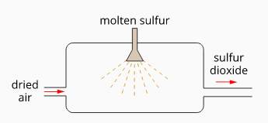Sulfur is usually sourced from the by-products of other industrial processes, including:

* Refining of natural gas and crude oil
* Smelting of sulfide ores of copper, zinc or lead

A fine mist of molten sulfur is sprayed into a burner, and the high surface area of the sulfur spray ensures rapid combustion.

## Stage 2: Converting sulfur dioxide into sulfur trioxide

Sulfur dioxide gas is oxidised by oxygen to form sulfur trioxide gas:

2SO2(g) + O2(g) ⇌ 2SO3(g) ΔH=−197 kJ mol−1

* The reaction between sulfur dioxide and oxygen is exothermic and contains more gaseous reactant particles than gaseous product particles (similar to the Haber process).
* 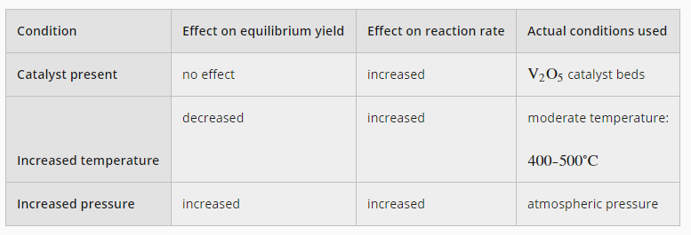From our knowledge of collision theory and Le Châtelier's principle, we can determine that:

### Actual Conditions Used

* 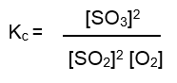High pressures would yield a high rate and yield, but unlike the Haber process, maintaining high pressures is not economical, so atmospheric pressures are used.
* 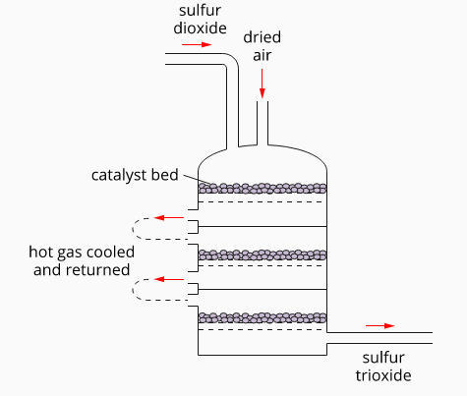Similar to the Haber process, a moderate temperature of 400–500∘C is used with a catalyst (vanadium (V) oxide, V2O5). This ensures a high enough reaction rate is achieved while producing reasonable yields. Since the reaction is strongly exothermic, the reactor gas is continuously removed, cooled, and returned to avoid overheating.
* Like the Haber process, the continual removal of sulfur trioxide prevents equilibrium and ensures a forward reaction progression.
* The use of excess O2 (the cheaper reagent) results in increased SO3 production. The oxygen can be cheaply sourced by using air

**The SO2 to SO3 converter**

This reaction is exothermic, so the gas mixture needs to be periodically cooled and returned to prevent overheating.

## Stage 3: Conversion of sulfur trioxide to sulfuric acid

Sulfur trioxide will react with water to form sulfuric acid:



However, due to the exothermic nature of the reaction and the hard-to-collect mist produced, sulfuric acid is not made directly like this.

Instead, a two-stage process is used:

* 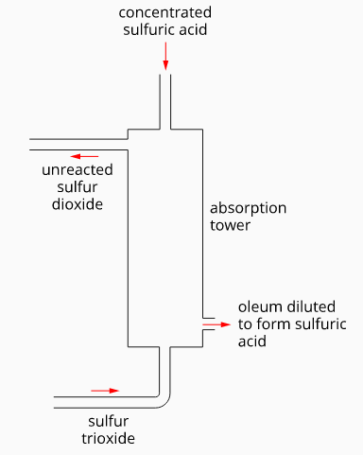The sulfur trioxide gas is passed through concentrated sulfuric acid in an absorption tower to form a liquid known as oleum, H2S2O7.

The incoming gas mixture still contains SO2, recycled in the SO2 converter. This process is called double absorption. It slightly increases recovery (from 98% to 99.6%) and significantly reduces the release of environmentally harmful SO2.

* This is followed by dilution of the oleum to form sulfuric acid



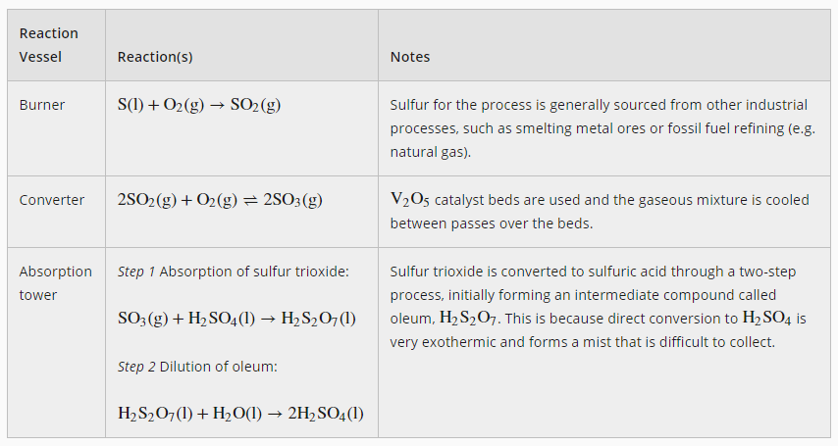

# Soaps and Detergents (Pearson 16.2 and 16.3)

Soap is a common name for the salts of long-chain carboxylic acids (fatty acids). They all contain a long hydrocarbon chain attached to a charged end (carboxylate group).

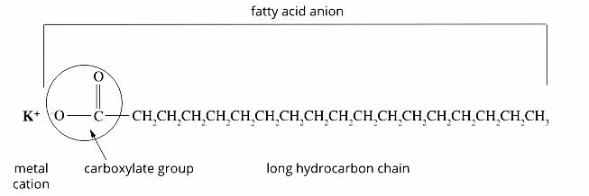

All soaps are made up of:

* a long hydrocarbon chain.
* a [carboxylate](http://lightbook.pearsonplaces.com.au/CH12_WA/units/CH12_WA-U04/chapters/CH12_WA-U04-16/modules/CH12_WA-U04-16-01/pages/Psec04302015192242810348/topics/Tsec07222015114832067603#sec06082015143739834605) ion, COO, attached to the hydrocarbon tail. Carboxylate ions are the conjugate bases of carboxylic acids.
* a metal ion.

## Soap Production

Base hydrolysis refers to using of alkaline conditions to assist the hydrolysis (bond breaking) action of water.

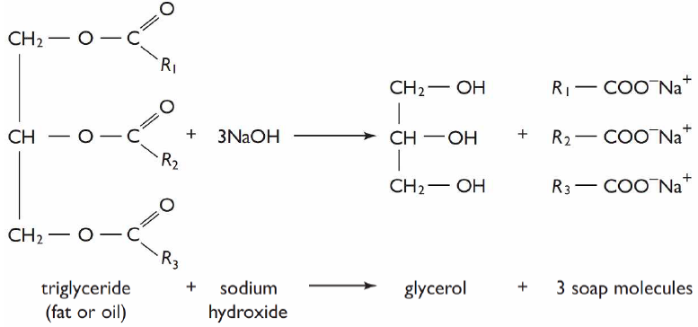Soap is produced by the base hydrolysis of triglycerides (fat/oil), called saponification. This process often involves heating fat/oil with added concentrated sodium hydroxide. It is then rinsed and set into moulds.

The base used does affect the properties of the soap produced. Sodium soaps, prepared from sodium hydroxide, are firm, whereas potassium soaps, derived from potassium hydroxide, are softer or often liquid.

3 fatty acid salts (soap particles)

The final product is usually a mixture of different soap particles, as most fats/oils are a mixture of triglycerides, and each triglyceride often consists of various fatty acid chains (R1, R2, R3).

## The Cleaning Action of Soaps

* A polar molecule will dissolve in a polar solvent, but a non-polar molecule will not, 'like dissolves like.
* Small molecules can be described as polar or non-polar. However, long molecules can have non-polar and polar sections in one molecule. In water, the fatty acid salt splits into ions, with the negative ion consisting of a polar (water soluble) [carboxylate](http://lightbook.pearsonplaces.com.au/CH12_WA/units/CH12_WA-U04/chapters/CH12_WA-U04-16/modules/CH12_WA-U04-16-01/pages/Psec04302015192242810348/topics/Tsec07222015114832067603#sec06082015143739834605) “head” and a non-polar (fat-soluble) hydrocarbon “tail”. Soaps are, therefore, “amphiphilic” and therefore show both hydrophilic (“water-loving”) and lipophilic (“fat-loving”) properties.

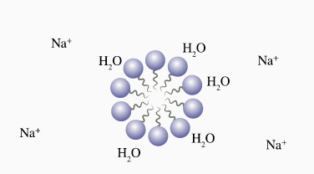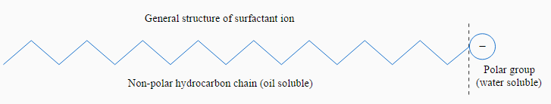

A soap micelle

* 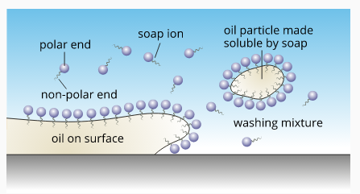In water, the non-polar ends of the soap ion try to avoid water by forming spherical structures called micelles.
* During the agitation of washing, the micelles are broken up, and the non-polar ends can position themselves in fat /oil drops. The polar (water soluble) ends attach to the surrounding water molecules and, with further agitation, lift the oil drops from the fabric / or greasy surface.

## Soap in Hard Water

* Hard water refers to water with a high metallic ion content. The metal ions usually present in hard water are Ca2+, Mg2+ and Fe2+ ions.
* When a typical soap is added to hard water, the stearate (soap) ions mix with the calcium and magnesium ions. At the same time, sodium stearate is soluble, but calcium and magnesium stearates are not and form a precipitate.

**“Action of hard water on soap”**

* Because the soap ions are used during the precipitation, a larger quantity of soap must be used to ensure an effective wash. Another problem is the insoluble precipitate “soap scum” coats sinks and drains.
* Hard water can be softened (lowered in metallic ions) by adding other –ve ions (e.g., carbonate, CO32-) to remove the metallic ions before washing.

**“Softening of hard water”**

## Detergents

* A synthetic soap alternative (another substance with long non-polar chains and charged ends).
* Sourced from “fossil fuels hydrocarbons” rather than animal and plant triglycerides.
* Like soap, detergents are “amphiphilic” and display a similar cleaning mechanism.

## Anionic (negativity-charged) detergents

Alkylbenzenesulfonates 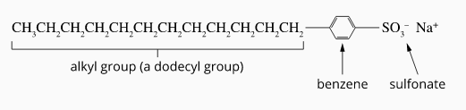are the most commonly produced detergent.

These detergents consist of:

* 'Alkyl' refers to the non-polar hydrocarbon chain. 'Dodecyl-' means the hydrocarbon chain contains 12 carbon atoms.
* 'Benzene' is a hexagonally shaped aromatic hydrocarbon.
* 'Sulfonate' refers to adding a -SO3 group to make a negatively charged end.

These detergents are more soluble in hard water because the polar sulfonate (detergents) is less likely than the polar carboxyl (of soap) to bind to calcium and other ions found in hard water.

## Formation of alkylbenzenesulfonates

**Biodiesel Synthesis (Pearson 16.4)**

A “biodiesel” molecule

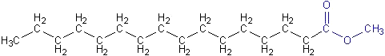

The term **'biodiesel'** refers to a diesel substitute consisting of a mixture* of esters produced by the reaction of a triglyceride (fat/oil) and an alcohol (usually methanol).

**Glycerol** is a type of (polyol), **a**n alcohol containing multiple hydroxyl groups.

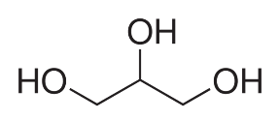

A glycerol molecule

*The exact mixture depends on the triglyceride and the alcohol used.

A **triglyceride** (**fat/oil)** is an ester derived from glycerol (alcohol) and three medium to long-chain carboxylic acids (fatty acids). They can be classified as saturated or unsaturated triglycerides.

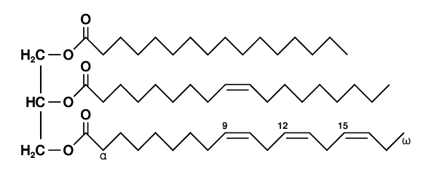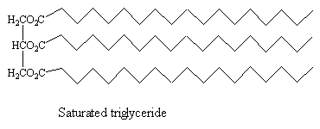

saturated triglyceride

unsaturated triglyceride

**Transesterification** is the process of exchanging the organic group R″ of an ester with the organic group R′ of an alcohol.

Triglycerides are converted into biodiesel by warming them with an alcohol, usually methanol, in a process known as **transesterification.**

Each triglyceride molecule is converted into three methyl/ethyl esters (fatty acid esters) and one glycerol molecule in this reaction.

**Transesterification General Equation**

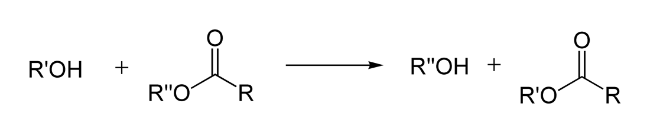

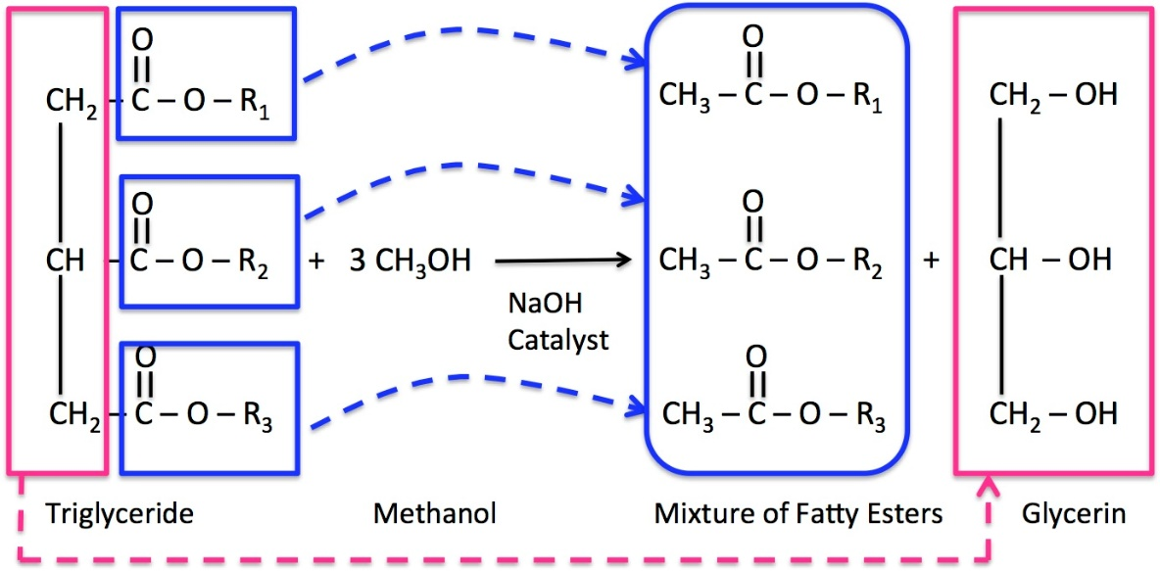

**Glycerol**

**“Biodiesel””**

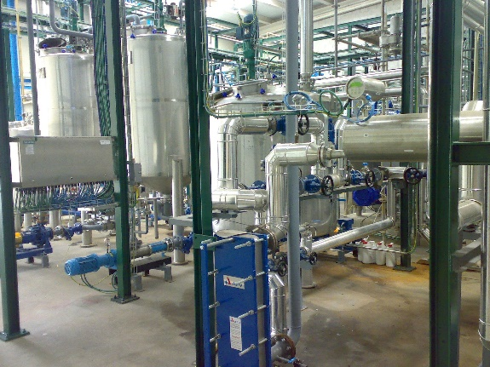**Reaction Rate Considerations**

To speed up this slow reaction:

* A basic catalyst (e.g. NaOH) is usually used.
* Moderate temperatures (≈60oC) are used. Temperatures higher than this would lead to excessive vaporisation of the alcohol (boiling point 65 oC at 1 atm). Even at these temperatures, there will be some vaporisation and a “closed” reactor is usually used.

**Yield Considerations:**

* Methanol is preferred to ethanol due to higher yields
* Alcohol is added in excess ≈ 6:1 alcohol to triglyceride ratio, rather than stoichiometric 3:1, to shift the equilibrium to the right.
* The immiscibility of the products also helps shift the equilibrium to the right.
* The amount of basic catalyst needs to be kept below a mole ratio of 3:1 base to triglyceride, as elevated base levels can lead to soap production, which would cause plant problems and reduce yield.

**The Industrial 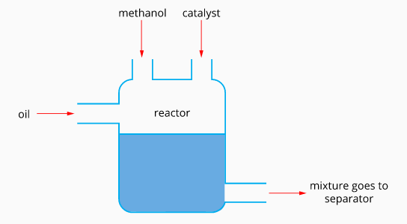Process**

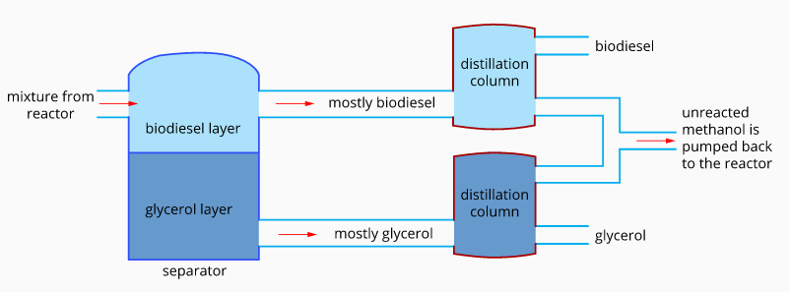

**Process Summary:**

Unlike most industrial processes, biodiesel synthesis is run as a “batch process”.

**Boiling Point Data**

Methanol 65 oC

Biodiesel 315 - 350 oC

Glycerol 290 oC

* Reagents are added to a reactor and heated for around 30 minutes.
* After reaction completion, the mixture is pumped into a separator (the biodiesel forms a layer at the top due to its lower density).
* The mixture is then reheated to distil out unreacted methanol from the biodiesel and glycerol (the methanol was added initially in excess). This unreacted methanol can be recycled.
* This process can result in a biodiesel yield of up to 98%.

**Alternate Catalyst**

The enzyme lipase can also be used to catalyse the reaction. However, there are several disadvantages:

* The reaction must be run at lower temperatures (to avoid denaturing the enzyme). This dramatically reduces the reaction rate of an already slow reaction.
* The yield for the enzyme catalyst reaction is much lower (possibly as low as 80%).

At present, nearly all biodiesel plants use the base-catalysed reaction.

# http://www.anchorbrewing.com/blog/wp-content/uploads/2013/08/Anchor-Fermenter-Room-300.jpgEthanol Synthesis (Pearson 18.4)

Ethanol is extensively used in alcoholic beverages as a significant component of methylated spirits and as an additive/replacement for petrol.

Ethanol synthesis extensively uses biological catalysts (enzymes). Unlike inorganic catalysts, enzymes are “reaction specific” and only function properly under limited environmental conditions.

## Raw material sources

Starches and sugars found in biomass are commonly used as raw materials for fermentation. These can be sourced from natural materials such as grains, potatoes, sugar cane, honey or fruit.

## Industrial Production of Ethanol

## Stage 1: Breakdown of Polysaccharides to Monosaccharides

**Malting** is a process where grains are allowed to germinate by soaking them in water, then drying in hot air to stop the germination process.This is done to allow the enzymes required for Stage 1 to develop in the grain.

* Malted grains are prepared by grinding and crushing, adding water, adjusting pH to 6 and then heating to 85–105∘C. Amylase (a natural enzyme found within the malted grain) results in the break-down of the polysaccharides (starch) in the grain into simpler sugar molecules such as glucose (a monosaccharide).
* The grain is removed from the mixture, leaving a sugar-rich solution ( “wort”) that is fermented in the next stage.
* Some source materials contain simple sugars instead of starch (e.g. grapes, honey, and sugar cane). These can be fermented directly without this stage. For example, grapes are crushed and filtered to remove the juice.

## Stage 2: Fermentation

**Yeast** are living organisms that can respire (produce energy in their cells) even in the absence of oxygen this is referred to as anaerobic respiration. Anaerobic means “without oxygen”.

Fermentation refers to a process where simple sugars (glucose/fructose) are converted to carbon dioxide and ethanol due to **anaerobic respiration** occurring within a living organism called yeast. Enzymes produced by the yeast catalyse this process.

The reaction can be written as:

glucose / fructose 🡪 ethanol + carbon dioxide

The cooled liquid from Stage 1 is added to a fermentation tank. The yeast is then added, and the solution is allowed to ferment until either the fermentable sugars are used up or the alcohol content prevents further fermentation (usually <15% ethanol, dependent on the yeast used). Many alcoholic beverages (e.g. beer and wine) are packaged after this stage, without Stage 3.

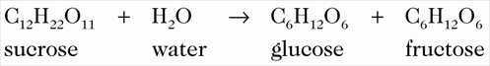Another yeast-catalysed reaction that may occur during this stage (before the fermentation reaction) is the **hydrolysis of sucrose** (a disaccharide) to monosaccharides (glucose and fructose). This is likely if the fermented mixture is from a sucrose-rich source, e.g., sugar cane or honey, or if sucrose was added to the mixture.

## Fermentation Considerations

Glucose and fructose are structural isotopes of C6H12O6

* As the catalyst is an enzyme, the temperature and pH of the reaction need to be maintained at the enzyme's “optimum point”. Too cold a temperature will slow the process, whilst too high a temperature will denature the enzymes. Ethanol is commonly fermented at temperatures of 20 –30oC. Since fermentation is exothermic, cooling is usually needed. Generally, conditions are maintained weakly acidic to encourage yeast growth.
* 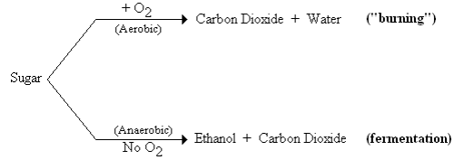The initial reaction is aerobic respiration. As a layer of CO2 builds up over the fermenter, the conditions become anaerobic, and the yeast starts using anaerobic respiration and forms ethanol.
* The yield (% of sugar converted to alcohol) depends on the type and concentration of sugars present and the type of yeast used.

## Stage 3: Distillation

Distillation can then be used to increase the alcohol content of the fermented solution. Alcoholic beverages like rum or scotch (alcoholic spirits) commonly contain 40% ethanol, whilst alcohol of up to 97.6%* ethanol is used in producing methylated spirits or as an additive to fuel.

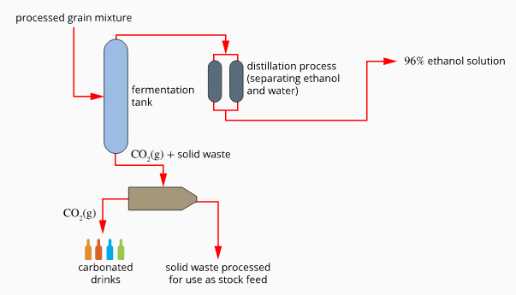*Distillation can concentrate ethanol up to 96%, and other industrial methods can remove further water and produce a product of 99.7% ethanol.

The boiling point of ethanol, 78oC, is close to the boiling point of water, 100oC. Therefore, the initial distillation product still contains a substantial proportion of water. Multiple distillation stages are commonly required, even for alcoholic beverages of 40% ethanol.

A “side effect” of distillation is the removal of many unwanted compounds. This is particularly important if the product is an alcoholic beverage.

## Other Ethanol Production Methods

Catalytic Cracking:

A process where large carbon-based molecules from crude oil are broken up into small molecules using a catalyst and a moderate temperature.

Around 7% of the total ethanol produced is produced by the additional reaction between ethene and water (hydration). Like most small hydrocarbons, ethene is obtained from the **catalytic cracking** of larger hydrocarbon molecules found in crude oil. Ethene is reacted with steam using an acidic catalyst to produce ethanol. This equation can represent the reaction:

This gaseous reaction is similar to the “Haber process” and the reactor phase of the “contact process”. Like the Haber process, it is conducted at moderate temperatures and high pressures and uses a catalyst.

The amount of steam added is less than the stoichiometric ratio of 1:1, making steam the limiting reagent. This reduces the dilution of the alcohol (less distillation is needed) and stops the loss of the acidic catalyst.

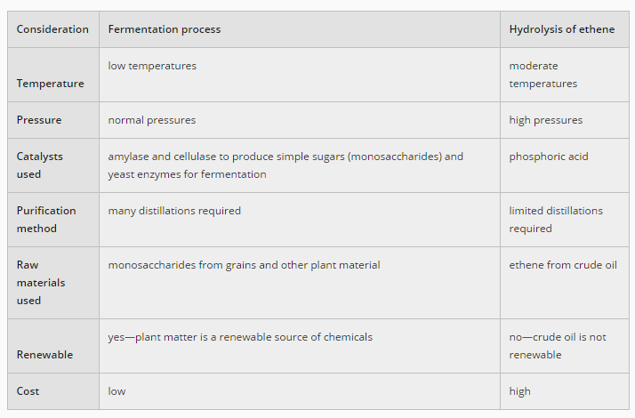With recycling, a final yield of 95% conversion can be achieved. Ethanol produced by this method is not used for alcoholic beverages.

The two methods of ethanol production are compared on the right.

## Environmental Considerations

Fermentation uses renewable resources (biomass). Burning biofuels like ethanol reduces the atmospheric CO2 effect because atmospheric carbon is incorporated into plants through photosynthesis. Bioethanol production and burning release less toxic by-products (e.g., soot, SO2,or NOx) into the atmosphere.

Ethanol produced from ethene is not a biofuel, so it does not have the environmental advantages of biofuel. Fossil fuels are nonrenewable, resulting in more CO2 being released into the atmosphere. Fossil fuel use also releases unwanted toxic substances, both from the production of ethane and the use of an acidic catalyst.

